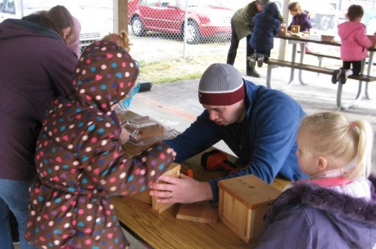
Mission Statement
We partner with parents
and the community to enhance and develop the social/emotional and school readiness skills of children and the
self sufficiency of
families.
Building bird houses on Dad’s Day!
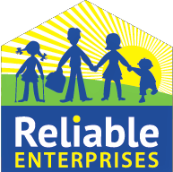

Completed March 2023
Lewis County Head Start
2021—2022
Annual Report

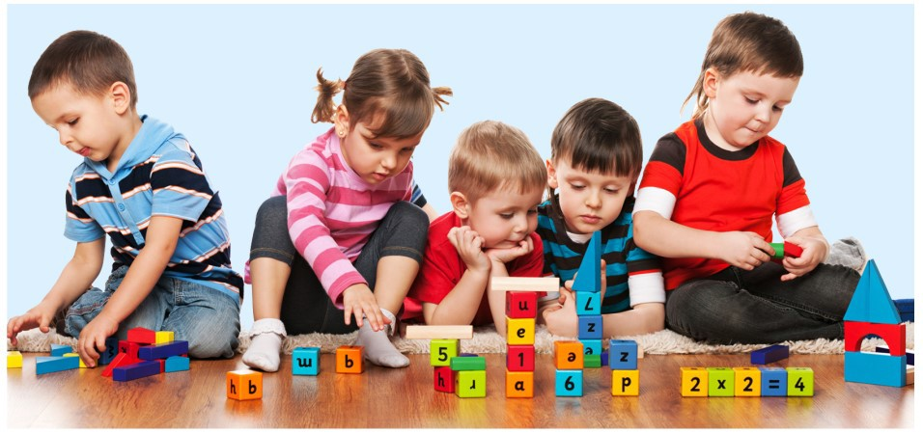

Lewis County Head Start

203 W Reynolds Ave. Centralia, WA 98531 Phone:360-736-1696 Fax: 360-736-0090
Linking Community, Home & School
Email:: lchs@lewiscountyheadstart.org

Enrolled Children Received Medical & Dental Exams
Efforts to Prepare Children for Kindergarten

Eligible Children & Enrollment
Review and Audit Statement

75 children transitioned from the program into kindergarten. The percentages of children meeting widely held expectations and determined to be “ready for kindergarten” by domain:

Social and Emotional Development: 96%
Approaches To Learning: | 96%
Cognition, Math & Science: | 87%
Perceptual Motor/Physical Health: | 95%
Language and Literacy: | 90%

It is the comprehensive nature of Head Start pro- gram services for staff to work with families to assure that children receive an annual well child exam and dental exam. In fiscal year 2021/22:
- 94% of children were up-to-date on a schedule of immunizations.
- 100% had health insurance.
- 89% were up-to-date on a schedule of health care.
- 11% needed follow-up treatment for chronic medical conditions such as asthma or allergies.
- 95% of children received dental exams.
For fiscal year 2021/22, Lewis County Head Start was funded to serve 173 children/families in Lewis County. Due to Covid 19 total enrollment served- 133

Cumulative Enrollment of Children | 133
Three-Year Olds | 58
Four-Year Olds | 75
Percentage of Category Eligible Families | 32%
Percentage of Families at 100% Federal Poverty | 50%
Percentage of Families at 130% Federal Poverty | 13%
Percentage of Families Over Federal Poverty Income | 1%
Children with an IEP | 12%
Number of Families Experiencing Homelessness | 26
Number of Homeless Families Acquired Housing | 4
Percentage of Families Primary Language - English | 92%
Percentage of Families Primary Language - Spanish | 2%
Number of Two Parent Families | 66
Number of Single Parent Families | 59
Percentage of Families Working | 58%

Information About Parent and Community Involvement Activities

Parent and community involvement and engagement are vital to the success of our children and program, and the community as a whole.
Number of Participating Fathers | 124
Total Number of parents in job training/school | 78
Number of Family School Readiness Events
Activities Provided by the Program | 15

Audit:
- Reliable Enterprises is a private non-profit agency, had no findings for the 504c3
Audit completed for fiscal year 2021/22

2021/22 Monitoring & Reviews:
Child Adult Care Food Program did not complete formal reviews/no dis-allowed meals

Head Start Grantee Annual Budget Information

Total Public Funding
100% Head Start -Budget vs. Actual

Category | Budgeted | Actual
Personnel | $1,133,646.56 | $852,642.35
Fringe Benefits | $440,200.19 | $343,941.22  $355,390.21
Travel | $3,325.00 | $3,183.09
Equipment | $0.00 | $0.00
Supplies | $11,850.00 | $35,500.22
Contractual | $98,726.60 | $122,651.74
Other | $402,609.32 | $576,560.97
Indirect | $234,488.32 | $220,060.31
Child & Adult Care Food Program:
Program Reimbursement $64,152.49

